
St Hugh’s College
Graduate Accommodation
Information Booklet
2024-25

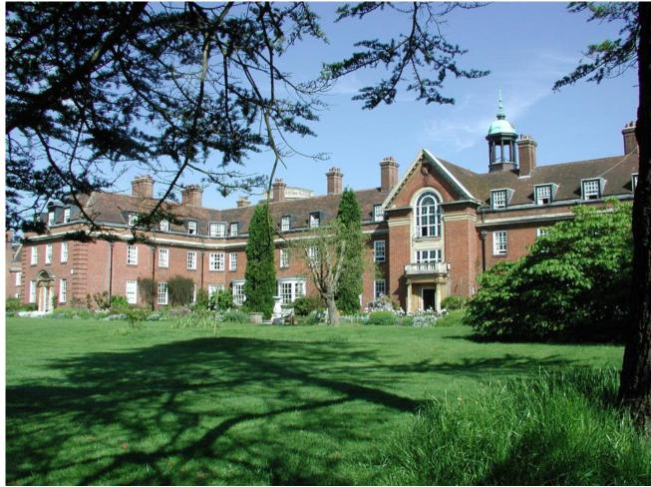

Contents

- Brief Overview Page 3

- 87 Banbury Road Page 4

- Dickson Poon China Centre Page 7

- East Cottage Page 8

- The Stables Page 9

- West Cottage Page 9

- 10 Canterbury Road Page 10

- 11 Canterbury Road Page 12

- 12 Canterbury Road Page 13

- 13 canterbury Road Page 15

- Room Bands (2023/2024) Page 16

Brief Overview

St Hugh’s College guarantees at least 84 rooms to its graduate students. The College aims to exceed this guarantee every year in order to demonstrate its commitment to St Hugh’s graduates.
St Hugh’s cannot guarantee all graduates accommodation, but the College does follow a selection criteria.
Of those 84 rooms, 69 are ensuite with shared kitchen facilities and one accessible self-contained studio. There are a further 14 single rooms with shared bathrooms and kitchens and one self-contained studio suitable for a couple/double occupancy.
St Hugh’s graduate accommodation is situated on College grounds, in shared houses and the newly built Dickson Poon Building. The dedicated graduate accommodation areas of the College are – 87 Banbury Road, East Cottage, West Cottage, The Stables and the Dickson Poon Building. See map below.

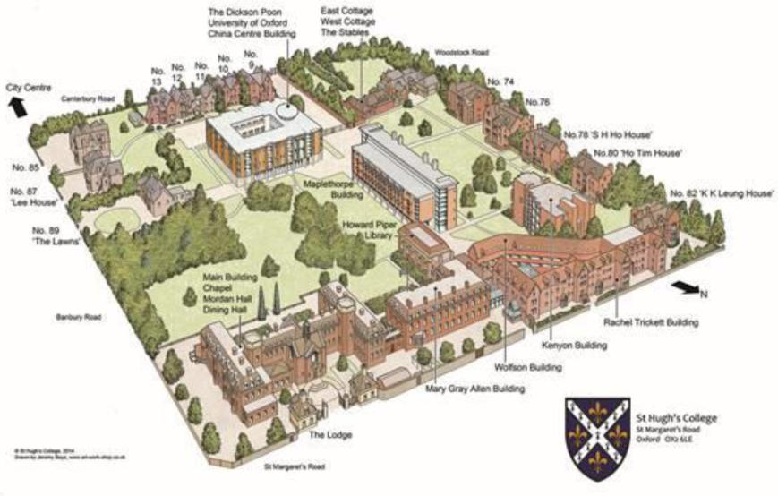
All study bedrooms will be supplied with the following as a minimum – bed, mattress, mattress protector, desk, desk chair, desk lamp, chest of drawers or similar storage space provided in the built-in wardrobe, wardrobe, easy chair, bedside table (if space), noticeboard.
A description of each house and room can be found in the following pages.

87 Banbury Road – MCR House

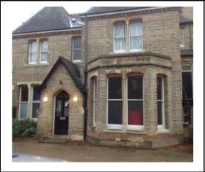
No of Bedrooms: 11
of which are ensuite: 5
No of Kitchens: 3
No of Toilets: 5
No of Baths: 1
No of Showers: 3

Message from the MCR Committee:
"First of all, congratulations on getting into St Hugh’s! We look forward to welcoming you when you arrive.
As housing applications are released, we would like to send this message to help with housing selection: As outlined in the housing guide, the MCR House (87 Banbury), by its nature, is a very social space. We understand that every year, students may choose the house in anticipation of the social atmosphere or be offered the house without a choice. However, throughout the terms, the occasional student realises they actually can’t tolerate the sound. This is a conflicting scenario for the MCR Committee as we work very hard to put on events for the student body. We ask that as you apply for residence and before you sign the contract to live in the MCR House, or any house facing the MCR, to please contemplate carefully whether you are able to live amid the noise produced from the shared communal space. We understand the inconvenience this may impose, but as a college that prides itself in the vibrant MCR community, we decided to send this message to best support creating social events that could foster this friendly, active MCR. Good luck on the applications!"

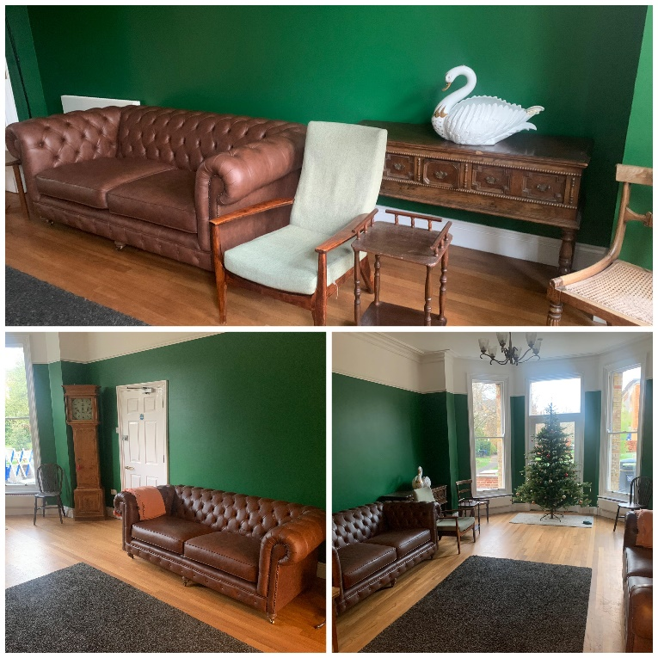
Basement
Large TV lounge area, WCs
Large kitchen - 1 x Fridge/Freezer,
1 x Cooker, 1 x Microwave, 1 x Kettle,
1 x Toaster and Table and Chairs
Laundry Facilities (contactless payment)
Ground Floor
Large Common/Party Room
Small kitchen area
MCR Study Room

First Floor
Large kitchen - 2 X fridges, 1 x freezer, 1 x cooker, 1 x microwave, 1 x kettle, 1 x toaster and
table and chairs
Shower room with shower cubicle, toilet and sink
Room 1 – Band 2 (12.14m²) –
A band 2 room situated on the lower landing next to a shower room which is only shared
with one other room as the rest of the bedrooms in this area are ensuite. The room has windows to the side and back of the room, both facing College grounds.
Room 2 – Band 2 (10.31m²) – Ensuite
A band 2 room with an ensuite bathroom consisting of a shower, sink and toilet, situated on the lower landing. The room has one window to the side facing the Banbury Road.
Room 3 – Band 2 (13.24m²)
A band 2 room situated on the lower landing. The nearest shower room is just down the
corridor and only shared by one other room as the other rooms in this area are ensuite. The room has a window that faces into the College.
Room 4 – Band 7 (20.56m²) – Ensuite
A band 7 room situated on the upper landing next to the kitchen. The room has a bay window which faces into the College.
Room 5 – Band 6 (15.62m²) – Ensuite
A band 6 room situated on the upper landing opposite the kitchen. The room has 2 windows facing the Banbury Road.
Room 6 – Band 7 (22.98m²) – Ensuite
A band 7 room situated on the upper landing opposite the kitchen. The room has 2 windows facing the Banbury Road.
Second Floor –
Kitchen - 1 x fridge/freezer, 1 x fridge, 1 x cooker, 1 x microwave, 1 x kettle,
1 x toaster and table and chairs.
2 x shower rooms with shower cubicles, toilet and sink
Separate toilet and a bathroom with bath, toilet and sink
Room 7 – Band 2 (13.13m²)
A band 2 room situated on the lower landing of the second floor. The room has windows to the side and back of the room both facing towards the College grounds.
Room 8 – Band 2 (10.18m²) – Ensuite
A band 2 room with an ensuite bathroom consisting of a shower, sink and toilet, situated on
the lower landing of the second floor. The room has one window to the side facing the Banbury Road.
Room 9 – Band 2 (13.29m²)
A band 2 room situated on the lower landing of the second floor. The room has a window that faces towards the College grounds.
Room 10 – Band 2 (12.61m²)
A band 2 room situated on the upper landing of the second floor. The room has sloping eaves and one window which faces towards the College grounds.
Room 11 – Band 1 (10.72m²)
A band 1 room situated on the upper landing of the second floor. The room has sloping eaves and one window to the side which faces the Banbury Road.

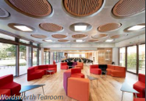
Dickson Poon Building
No of Bedrooms: 63
No of Kitchens: 8
Lifts: 2
Band 3: £666
Band 5: £703

Studio: £885

63 high quality ensuite graduate bedrooms

The building is split into two wings: The Andrew Dilnot Wing and The Wolfson Foundation Wing.
Andrew Dilnot Wing – Accommodates graduate students on 9-month leases only. Tenancies commence 27th September and end on 26th June the following year.
Wolfson Foundation Wing – Accommodates students on 12-month leases. Tenancies commence 27th September and end on 26th September the following year.

There are two lifts in the building accessing all levels. The Wordsworth Tea Room is situated on the ground floor of this building, usually opened 9.30am- 4.30 pm during term time for anyone wishing to purchase additional breakfast, lunch or snacks.

All study bedrooms will be supplied with the following as a minimum – bed, mattress, mattress protector, desk, desk chair, desk lamp, wardrobe, easy chair, bedside table (if space), noticeboard.
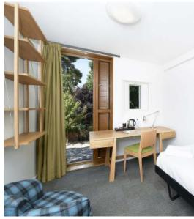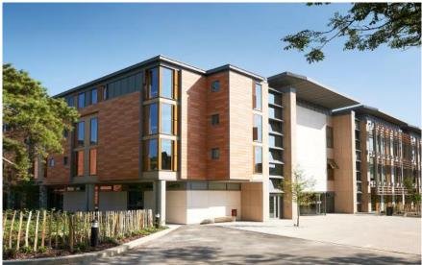

East Cottage (72 Woodstock Road)
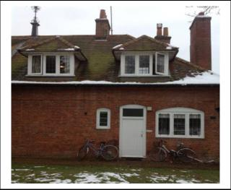
No of Bedrooms: | 3
No of Kitchens: | 1
No of Toilets: | 1
No of Baths: | 1
No of Showers: | 1

First Floor

Kitchen - 1 x fridge/freezer, 1 x cooker, 1 x microwave, 1 x kettle, 1 x toaster
Dining area with table and chairs
Bathroom with bath, shower over bath, sink and toilet

Room 1 – Band 7 (30.66m²)
A band 7 room situated at the front of the property. The room has many windows facing the Principal’s lawn and the Fellows’ garden.

Room 2 – Band 1 (10.27m²)
A band 1 room situated in the front of the property. The room has a window which faces the Principal’s lawn.

Room 3 – Band 2 (14.14m²)
A band 2 room situated at the back of the property. The room has a window which faces towards the College grounds.

The Stables (72 Woodstock Road) – Studio

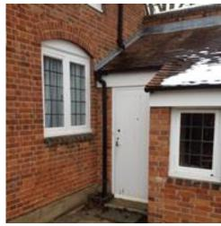
The studio consists of 3 rooms.
There is a large bedroom/living/dining area with a double bed,
wardrobe, chest of drawers, sofa, armchair, coffee table,
dining table and chairs.
There is a separate kitchen with a sink, cooker,
fridge, microwave, kettle and toaster. There is also a bathroom,
including a toilet, sink, bath and a shower.

West Cottage (72 Woodstock Road)
No of bedrooms: 3
No of Kitchens: 1
No of Toilets: 1
No of Baths: 1
No of Showers: 1

Kitchen - 1 x fridge/freezer, 1 x cooker, 1 x microwave, 1 x kettle, 1 x toaster Bathroom with bath, sink and a separate toilet with a wash basin.
Room 1 – Band 4 (17.1m²)
A band 4 room situated at the front of the house. The room has a window facing the Principal’s lawn.

First Floor
Room 2 – Band 4 (16.8m²)
A band 4 room situated at the front of the house. The room has a window which faces the Principals lawn.

Room 3 – Band 4 (16.8m²)
A band 4 room situated at the rear of the house. The room has a window which faces towards the College ground
10 Canterbury Road
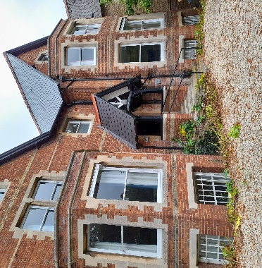
No of bedrooms: 15
No of Kitchens: 4
No of Toilets: 5
No of Baths: 3
No of Showers: 3

Basement

Kitchen - 1 x fridge/freezer, 1 x cooker, 1 x microwave, 1 x kettle, 1 x toaster
Dining area with table and chairs
Bathroom with bath, shower over bath, sink and toilet

Room 1 – Band 3 (16.65m²)

Room 2 – Band 4 (20.40m²)

Room 3 – band 6 (25.18m²)

Ground Floor

Kitchen - 1 x fridge/freezer, 1 x cooker, 1 x microwave, 1 x kettle, 1 x toaster
Bathroom with bath, shower over bath, sink and toilet

Room 5 – Band 4 (22.13m²)

Room 6 – Band Studio (31.49m²)

Room 7 – Band 2 (12.90m²)

Room 8 – Band 2 (11.51m²)

First Floor

Kitchen - 1 x fridge/freezer, 1 x cooker, 1 x microwave, 1 x kettle, 1 x toaster
Dining area with table and chairs
Bathroom with bath, shower over bath, sink and toilet
Toilet

Room 9 – Band 3 (17.85m²)

Room 10 – Band 3 (18.98m²)

Room 11 – Band 7 (31.46m²)

Second Floor

Kitchen - 1 x fridge/freezer, 1 x cooker, 1 x microwave, 1 x kettle, 1 x toaster
Dining area with table and chairs
Toilet
Shower Room

Room 12 – Band 2 (14.17m²)

Room 13 – Band 2 (14.52m²)

Room 14 – Band 4 (22.15m²)

Room 15 – band 2 (13.63m²)

11 Canterbury Road

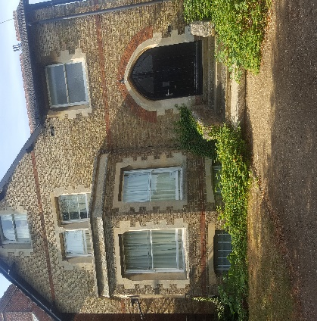
No of bedrooms: 7
No of Kitchens: 2
No of Toilets: 3
No of Baths: 2
No of Showers: 2

Basement

Kitchen - 1 x fridge/freezer, 1 x cooker, 1 x microwave, 1 x kettle, 1 x toaster
Bathroom with bath, shower over bath, sink and toilet

Room 1 – Band 6 (22.86m²)

Ground Floor

Room 2 – Band 6 (22.86m²)

Room 3 – Band 7 (27.17m²)

First Floor

Kitchen - 1 x fridge/freezer, 1 x cooker, 1 x microwave, 1 x kettle, 1 x toaster
Dining area with table and chairs
Toilet

Room 4 – band 6 (22.86m²)

Room 5 – Band 4 (15.72m²)

Second Floor

Bathroom with bath, shower over bath, sink and toilet

Room 7 – Band 2 (13.02m²)

Room 8 – Band 2 (13.96m²)

12 Canterbury Road

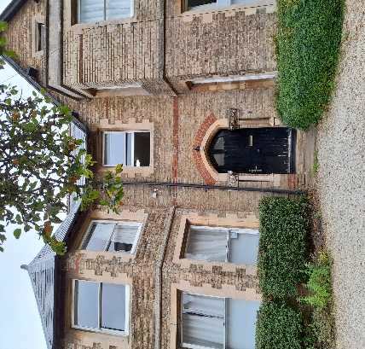
No of bedrooms: 7
No of Kitchens: 2
No of Toilets: 3
No of Baths: 2
No of Showers: 2

Ground Floor

Kitchen - 1 x fridge/freezer, 1 x cooker, 1 x microwave, 1 x kettle, 1 x toaster
Dining area with table and chairs
Toilet

Room 1 – Band 6 (21.53m²)

Room 2A – Band 4 (17.26m²)

Room 2B – Band 6 (24.52m²)

First Floor

Bathroom with bath, shower over bath, sink and toilet
Toilet
Shower Room

Room 3 – Band 6 (21.53m²)

Room 4 – Band 6 (20.96m²)

Room 5 – Band 6 (21.07m²)

Second Floor

Bathroom with bath, shower over bath, sink and toilet

Room 6 – Band 1 (11.01m²)
Room 7 – Band 2 (14.06m²)

Room 8 – Band 1 (11.29m²)

13 Canterbury Road

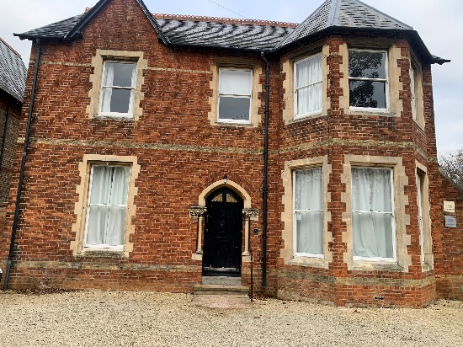
No of Bedrooms: 7

No of Kitchens: 1
No of Toilets: 3
No of Baths: 1
No of Showers: 2

Ground Floor

Kitchen - 1 x fridge/freezer, 1 x cooker, 1 x microwave, 1 x kettle, 1 x toaster
Dining area with table and chairs
Toilet
Laundry Room

Room 1 – Band 6 (20.52m²)

Room 2 – Band 1 (11.11m²)

First Floor

Bathroom with bath, shower over bath, sink and toilet
2 Shower Rooms
Toilet

Room 5 – Band 4 (15.72m²)

Room 7 – Band 2 (12.39m²)

Room 8 – Band 7 (26.24m²)

Second Floor

Toilet

Room 9 – Band 4 (15.54m²)

Room 10 – Band 6 (24.70m²)

2024/25 Room Bands

Graduate Room Bands and Rates 2024-25
Property | Room | Ensuite | Size | Band | Cost
87 Banbury Rd | 11 | 0 | 10.72 | 1 | £639.97
East Cottage | 2 | 0 | 10.27 | 1 | £639.97
10 Canterbury Rd | 4 | 0 | 11.52 | 1 | £639.97
12 Canterbury Rd | 6 | 0 | 11.01 | 1 | £639.97
12 Canterbury Rd | 8 | 0 | 11.29 | 1 | £639.97
13 Canterbury Rd | 2 | 0 | 11.11 | 1 | £639.97
87 Banbury Rd | 1 | 0 | 12.14 | 2 | £677.68
87 Banbury Rd | 2 | 1 | 10.31 | 2 | £677.68
87 Banbury Rd | 3 | 0 | 13.24 | 2 | £677.68
87 Banbury Rd | 7 | 0 | 13.13 | 2 | £677.68
87 Banbury Rd | 8 | 1 | 10.18 | 2 | £677.68
87 Banbury Rd | 9 | 0 | 13.29 | 2 | £677.68
87 Banbury Rd | 10 | 0 | 12.61 | 2 | £677.68
East Cottage | 3 | 0 | 14.14 | 2 | £677.68
10 Canterbury Rd | 7 | 0 | 12.90 | 2 | £677.68
10 Canterbury Rd | 8 | 0 | 11.51 | 2 | £677.68
10 Canterbury Rd | 12 | 0 | 14.17 | 2 | £677.68
10 Canterbury Rd | 13 | 0 | 14.52 | 2 | £677.68
10 Canterbury Rd | 15 | 0 | 13.63 | 2 | £677.68
11 Canterbury Rd | 7 | 0 | 13.02 | 2 | £677.68
11 Canterbury Rd | 8 | 0 | 13.96 | 2 | £677.68
12 Canterbury Rd | 7 | 0 | 14.06 | 2 | £677.68
13 Canterbury Rd | 7 | 0 | 12.39 | 2 | £677.68
DPB | DPB WFW 111 | 1 | 19.00 | 3 | £694.41
DPB | DPB WFW 112 | 1 | 19.00 | 3 | £694.41
DPB | DPB WFW 113 | 1 | 19.00 | 3 | £694.41
DPB | DPB WFW 114 | 1 | 19.00 | 3 | £694.41
DPB | DPB WFW 115 | 1 | 19.00 | 3 | £694.41
DPB | DPB WFW 116 | 1 | 19.00 | 3 | £694.41
DPB | DPB WFW 117 | 1 | 19.00 | 3 | £694.41
DPB | DPB WFW 118 | 1 | 19.00 | 3 | £694.41
DPB | DPB WFW 211 | 1 | 19.00 | 3 | £694.41
DPB | DPB WFW 212 | 1 | 19.00 | 3 | £694.41
DPB | DPB WFW 213 | 1 | 19.00 | 3 | £694.41
DPB | DPB WFW 214 | 1 | 19.00 | 3 | £694.41
DPB | DPB WFW 215 | 1 | 19.00 | 3 | £694.41
DPB | DPB WFW 216 | 1 | 19.00 | 3 | £694.41
DPB | DPB WFW 311 | 1 | 19.00 | 3 | £694.41
DPB | DPB WFW 312 | 1 | 19.00 | 3 | £694.41
DPB | DPB WFW 313 | 1 | 19.00 | 3 | £694.41
DPB | DPB WFW 314 | 1 | 19.00 | 3 | £694.41
DPB | DPB WFW 315 | 1 | 19.00 | 3 | £694.41
DPB | DPB WFW 316 | 1 | 19.00 | 3 | £694.41
DPB | DPB WFW 317 | 1 | 19.00 | 3 | £694.41
DPB | DPB ADW 102 | 1 | 19.00 | 3 | £694.41
DPB | DPB ADW 103 | 1 | 19.00 | 3 | £694.41
DPB | DPB ADW 104 | 1 | 19.00 | 3 | £694.41
DPB | DPB ADW 105 | 1 | 19.00 | 3 | £694.41
DPB | DPB ADW 106 | 1 | 19.00 | 3 | £694.41
DPB | DPB ADW 107 | 1 | 19.00 | 3 | £694.41
DPB | DPB ADW 202 | 1 | 19.00 | 3 | £694.41
DPB | DPB ADW 203 | 1 | 19.00 | 3 | £694.41
DPB | DPB ADW 204 | 1 | 19.00 | 3 | £694.41
DPB | DPB ADW 205 | 1 | 19.00 | 3 | £694.41
DPB | DPB ADW 206 | 1 | 19.00 | 3 | £694.41
DPB | DPB ADW 207 | 1 | 19.00 | 3 | £694.41
DPB | DPB ADW 302 | 1 | 19.00 | 3 | £694.41
DPB | DPB ADW 303 | 1 | 19.00 | 3 | £694.41
DPB | DPB ADW 304 | 1 | 19.00 | 3 | £694.41
DPB | DPB ADW 305 | 1 | 19.00 | 3 | £694.41
DPB | DPB ADW 306 | 1 | 19.00 | 3 | £694.41
DPB | DPB ADW 307 | 1 | 19.00 | 3 | £694.41
10 Canterbury Rd | 1 | 0 | 16.65 | 3 | £694.41
10 Canterbury Rd | 9 | 0 | 17.85 | 3 | £694.41
10 Canterbury Rd | 10 | 0 | 18.98 | 3 | £694.41
West Cottage | 1 | 0 | 17.10 | 4 | £709.93
West Cottage | 2 | 0 | 16.80 | 4 | £709.93
West Cottage | 3 | 0 | 16.80 | 4 | £709.93
10 Canterbury Rd | 2 | 0 | 20.40 | 4 | £709.93
10 Canterbury Rd | 5 | 0 | 22.13 | 4 | £709.93
10 Canterbury Rd | 14 | 0 | 22.15 | 4 | £709.93
11 Canterbury Rd | 5 | 0 | 15.72 | 4 | £709.93
12 Canterbury Rd | 2a | 0 | 17.26 | 4 | £709.93
13 Canterbury Rd | 5 | 0 | 18.89 | 4 | £709.93
13 Canterbury Rd | 9 | 0 | 15.54 | 4 | £709.93
DPB | DPB WFW 119 | 1 | 20.4m² | 5 | £733.04
DPB | DPB WFW 120 | 1 | 20.4m² | 5 | £733.04
DPB | DPB WFW 121 | 1 | 20.4m² | 5 | £733.04
DPB | DPB WFW 210 | 1 | 20.4m² | 5 | £733.04
DPB | DPB WFW 217 | 1 | 20.4m² | 5 | £733.04
DPB | DPB WFW 218 | 1 | 20.4m² | 5 | £733.04
DPB | DPB WFW 219 | 1 | 20.4m² | 5 | £733.04
DPB | DPB WFW 220 | 1 | 20.4m² | 5 | £733.04
DPB | DPB WFW 221 | 1 | 20.4m² | 5 | £733.04
DPB | DPB WFW 222 | 1 | 20.4m² | 5 | £733.04
DPB | DPB WFW 223 | 1 | 20.4m² | 5 | £733.04
DPB | DPB WFW 224 | 1 | 20.4m² | 5 | £733.04
DPB | DPB WFW 310 | 1 | 20.4m² | 5 | £733.04
DPB | DPB WFW 318 | 1 | 20.4m² | 5 | £733.04
DPB | DPB ADW 101 | 1 | 20.4m² | 5 | £733.04
DPB | DPB ADW 108 | 1 | 20.4m² | 5 | £733.04
DPB | DPB ADW 109 | 1 | 20.4m² | 5 | £733.04
DPB | DPB ADW 201 | 1 | 20.4m² | 5 | £733.04
DPB | DPB ADW 208 | 1 | 20.4m² | 5 | £733.04
DPB | DPB ADW 209 | 1 | 20.4m² | 5 | £733.04
DPB | DPB ADW 301 | 1 | 20.4m² | 5 | £733.04
DPB | DPB ADW 308 | 1 | 20.4m² | 5 | £733.04
DPB | DPB ADW 309 | 1 | 20.4m² | 5 | £733.04
87 Banbury Rd | 4 | 1 | 20.56 | 6 | £754.64
87 Banbury Rd | 5 | 1 | 15.62 | 6 | £754.64
10 Canterbury Rd | 3 | 0 | 25.18 | 6 | £754.64
11 Canterbury Rd | 1 | 0 | 22.86 | 6 | £754.64
11 Canterbury Rd | 4 | 0 | 22.86 | 6 | £754.64
11 Canterbury Rd | 2 | 0 | 22.86 | 6 | £754.64
12 Canterbury Rd | 1 | 0 |  | 6 | £754.64
12 Canterbury Rd | 3 | 0 | 21.53 | 6 | £754.64
12 Canterbury Rd | 4 | 0 | 20.96 | 6 | £754.64
12 Canterbury Rd | 5 | 0 | 21.07 | 6 | £754.64
12 Canterbury Rd | 2b | 0 | 24.52 | 6 | £754.64
13 Canterbury Rd | 1 | 0 | 20.52 | 6 | £754.64
13 Canterbury Rd | 10 | 0 | 24.70 | 6 | £754.64
87 Banbury Rd | 6 | 1 | 22.98 | 7 | £795.09
East Cottage | 1 | 0 | 30.66 | 7 | £795.09
10 Canterbury Rd | 11 | 0 | 31.46 | 7 | £795.09
11 Canterbury Rd | 3 | 0 | 27.17 | 7 | £795.09
13 Canterbury Rd | 8 | 0 | 26.24 | 7 | £795.09
72 Woodstock Rd | The Stables | 1 |  | Studio | £922.54
10 Canterbury Rd | 6 | 1 |  | Studio | £922.54
DPB | DPB WFW 110 | 1 | 19.00 | Studio | £922.54

