St Hugh’s College

Protocol for Tutorial Room Bookings

With the current social distancing measures likely to last some time, we have made some adaptations to tutorial room bookings. Please continue to make bookings with the Conference Office, by emailing academic.bookings@st-hughs.ox.ac.uk, and noting the number of people per booking.

We ask that you adhere to the 2m distancing set by the Government, and that face coverings are worn at all times.

Room layouts
All tutorial rooms will now be in a fixed classroom layout to facilitate social distancing. This is to reduce the frequency of staff needing to attend rooms to move furniture. The maximum room capacities listed below (page 3) include both student(s) and tutor. Please do not move furniture around.

Basic room hygiene
We ask that you use the products supplied to clean the room before you leave. One nominated person should take responsibility for this. Ensure that you wipe down the occupied area (table, chairs) with the wipes or disinfectant spray provided. The other touch areas such as PCs, door handles, whiteboard pens, touch screens equipment controls etc also need to be wiped down.

All rubbish and recycling to be placed in the bins provided.
All surfaces to be cleared of debris by the user after each meeting.

Personal hygiene
There are hand sanitizers located at key areas all over College and it is recommended you use these whenever you pass one. As in the corridors, face-coverings should be worn. Where possible, windows should be open throughout the tutorial, and left open when the room is vacated.

Attendee developing symptoms
If someone who has attended your tutorial develops symptoms of Covid-19, you must inform the Conference Office immediately so that the room can be closed for the minimum government recommended time, and then deep-cleaned before further use.

Time slots for tutorial bookings
We are introducing tutorial room hourly slots to help facilitate the demand for bookable tutorial space. Cleaning will be carried out between 07:00 – 08:00 and 12:00 – 13:00. Slots are followed by a 30 minute gap to allow the group to clean the room and depart before another group arrives.

All rooms must be booked in advance.

Morning 1 | Morning 2 | Afternoon 1 | Afternoon 2 | Afternoon 3
09:00 – 10:00 | 10:30 – 11:30 | 13:00 – 14:00 | 14:30 – 15:30 | 16:00 – 17:00

Personal belongings
Please ensure ALL personal belongings are removed at the end of your tutorial. Any items left behind will be disposed of.

Students from outside St Hugh’s
If you are inviting in students from other Colleges, please ask that they report to the Porters’ Lodge upon arrival.

Booking on behalf of an external tutor
From time to time, we receive requests from external tutors carrying out tutorials on behalf of a St Hugh’s Tutor. In cases like this, we need to know their name and address.

Safety
There is a bespoke usage protocol in each tutorial room, updated to include cleaning guidance. Please familiarise yourself with this document on entering the room. Where possible, windows must be left open at the end of each tutorial.

Register
Tutors are asked to keep a record of attendance for each tutorial, this includes both St Hugh’s students and external students. This is to enable contact tracing in the event of a positive test result. The register can be destroyed 21 days after the tutorial.

Waiting Areas
There are set waiting areas outside each tutorial room (exact locations are listed at the end of this document). Please convey this to all students who arrive for tutorials early. Rooms can only be accessed from the time booked.

Meeting Room Layouts

 | Room name | Max capacity
 | Maplethorpe Suite
1 | MTB Hall | 25
2 | MTB Seminar Room | 8
3 | MTB Office | 4
 | Mordan Hall Suite
4 | Mordan Hall | 18
5 | Hamlin 1 | 6
6 | Hamlin 2 | 4
7 | Dobbs 1 | 4
8 | Dobbs 2 | 6
 | 82 Woodstock Road
9 | Seminar Room | 4
10 | Old Law Library | 8
 | Mga Building
11 | MGA Lecture Room | 6
 | Dickson Poon Building – 2nd Floor
12 | Louey Seminar Room | 11
13 | Meeting Room 2  (next door to Louey Seminar Room) | 3

Waiting Area guidelines
Below are the locations of Waiting Areas for each Tutorial room. Please contact the Porters’ Lodge or the Conference Office if there are any issues.

Maplethorpe Suite (MTB)

MTB Hall

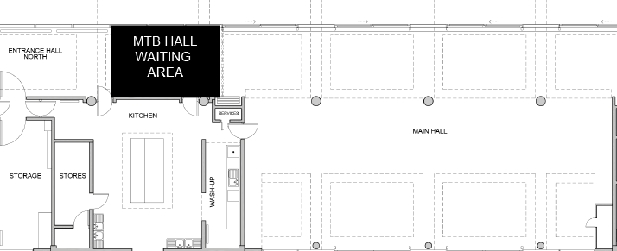

MTB Seminar Room

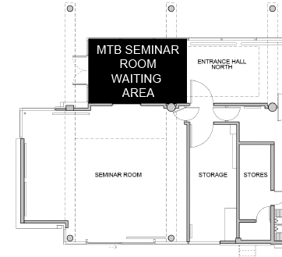

MTB Office
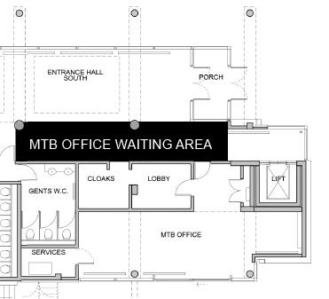

Mordan Hall Suite

Mordan Hall

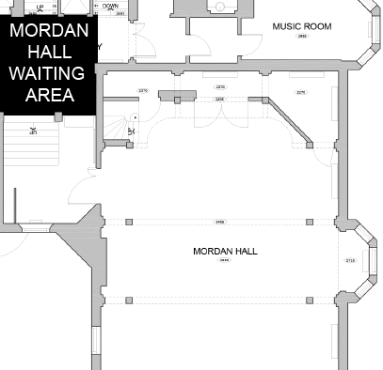

Hamlin 1 & Hamlin 2

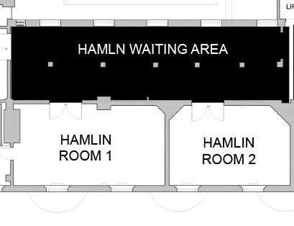

Dobbs 1 & Dobbs 2

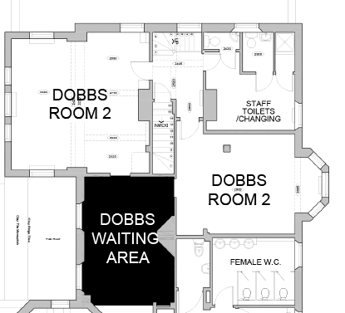

82 Woodstock Road

Seminar Room & Old Law Library

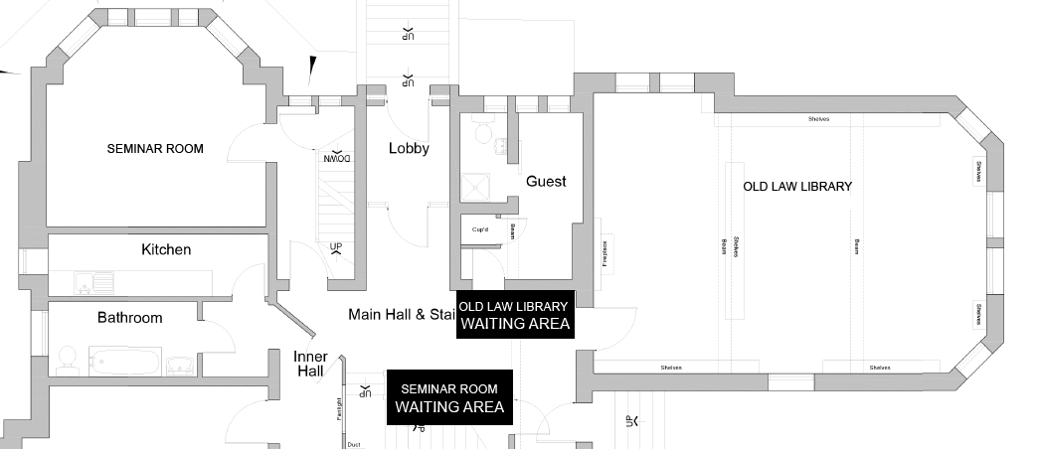

MGA Building

MGA Lecture Room

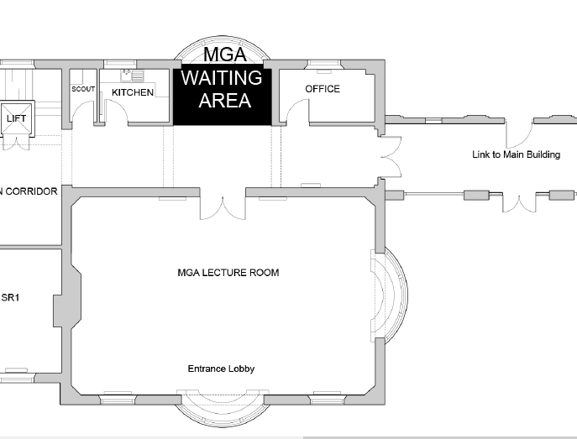

Dickson Poon Building (2nd floor)

Louey Seminar Room & Meeting Room 2

